Expanse Edu Business Plan Sampler

Compressed Highlights

Highlight Goals
- Engagement.
- Optimally Compressed.
- Maintain privacy.
- Prime the audience for learning.
- Eyes on the (+) branches. Additional value from problem solving the (-)’s

Introduction
Essence: Gamification of Education to nurture minds and unlock potential
Problems Targeted: Disengagement & Distraction, Declining Mental Health, Missing Purpose
Goals: Grow. Heal. Play.

Juicy Bits
Purpose: #1
Opportunity: Unicorn^{^2}
Innovation: Revolutionary
Need: Urgent
Timing: Prime
Scale: 360

Differentiators
Artificial Intelligence. Age. Easy to Use. Parents.

PowerUps
Cutting-Edge Technology + Processes.
Content x Passion.
<3 Game.

Marketing Strategy | (Meta)=>Pinnacle

User Audience:
Students >>> Parents >> Teachers > Districts

Sales & Marketing Audience
EntryPoint = Districts
Improving Adoption & Spread: Students & Parents > Districts > Teachers

Go To Market: Path
Root: Data -> Expansion -> Compression => Iteration
Life: Learn. Plan. Prove.
Seed: Sprout. Absorb. Peek.
Series A: Bloom. Shine. Play.
Series B: Data. Gap. Algorithms.
Series C: +China; ++Marketing Spend; +++Regional Features;
IPO: Charts.

Go To Market: Money & Income ( Starter )
Free to Play. Upgradable Memberships. | Reduces Barrier to Entry, Rapid Scaling
Pivot options for Free Trial > Districts Pay Per User
Variety of revenue sources, depends on time, and selected features.

Go To Market: Marketing, Sales, & Content
Core: Content is king. Brand as the foundation.
Timing: Wait -> Local -> Big
Context: Business Plan, Brand Data, Data, Trends, KC Case Study, & Real Stories.
Audience: User Personas & Audience Details.
Execution: Data, People, Social.
Tools & Resources: Data. Topic & Specializations. Presentations, Scripts, and Procedures

Funding
/^.*[Seed, A]+$/

Total Addressable Market
See the product.

Area Adjusted Student Counts Yearly Income ( Initial Target )
Missouri 1,000,000 7 Million / Year
US 70,000,000 500 Million / Year
Global 1,500,000,000 10 Billion / Year

Yearly Income assuming 10% @ 5.99/m for 12m
Actual Target: 6$ Trillion Market => 6$ Trillion+++

Validation
Status:
[ALOT] Proof of Need, [Moderate] Proof of Interest, [Some, Varies] Proof Of Solution
Online Research, Statistics, Studies.
Local Research, Case Study Phase 1 Performed in Kansas City Schools. Multiple conversations with Teachers, and Parents regarding needs. Countless engineers and college students interested in opportunities.

Team
Founder: Matthew McKeller, https://www.matthewmckeller.com/
Starting to Grow. Need Resources for security, privacy, and segmentation.
Ongoing project for acquiring educational advisors.

Success!
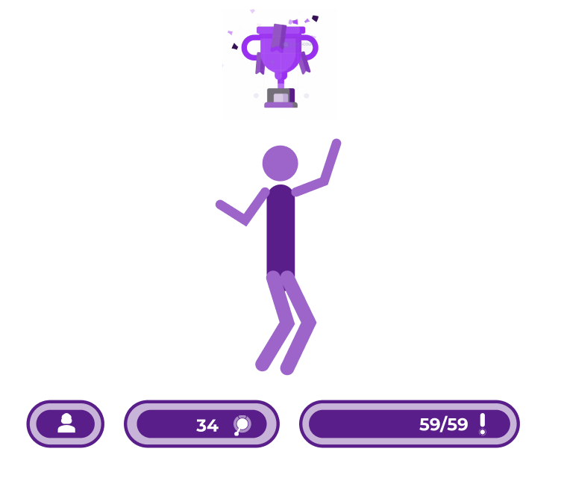
You have reached Level 2. Congratulations!

Business Plan Summary Sampler 2
Access for this content requires you to first achieve Level 2!

Note: For optimal learning, please re-read and take breaks in order maximize learning and informational retention.

This is still just samplers. See more details in the fully expanded versions of the business plan.

Document Goals
- Start Crafting the Picture of Where Expanse is, and the crucial foundations
- Explain why Expanse has decided to prioritize privacy and security
- Understanding. Expanding. Branching.
- Avoid Overload, but communicate important details.
- Communicate Expanse’s Current Needs

High Level Roadmap Highlights

Foundational Planning
[x][v1] Research & Innovation
[x][v1] Competition Research
[x][v3] Business Plan
[x][v3] Product Planning & Innovation
[x][v3] Pitch
[x][v2] Branding/Design Foundation Established w/ Theme & Core Assets
[x][v2] Content Targets Foundation Established
[x][v2] T-Shirt Sized Long Term Roadmapping & Prioritization
[x][v2] Starter Financials / Costs
[x] Application Foundations
[x] Stories & Research
[x] Longer Case Study of Low Engagement School
[x] Shorter Studies of High Performance and Standard Schools
[x] More Granular Short Term Roadmapping

Design / Implementation
I started many of the foundational pieces, gained knowledge in 99% of areas. Paused my implementations, drafted plans, and switched to leading and scaling.
[x] Starter Wireframes
[x] Partial Architecture/Infrastructure/Data/APIs
[x] Web Frontend & Backend Technology and Foundation Mostly Complete
[x] Major Foundational Integrations Successful
[x] Proof of Concept w/ Onboarding
[PAUSED/PREFERENTIALLY_BLOCKED] MVP
[PAUSED] Infrastructure & CI/CD Pipelines
[PAUSED] Security & Compliance
[PAUSED] Observability
[WIP] Marketing & Sales Foundations
[WIP] Funding
[WIP/PARTIALLY_BLOCKED] CoFounders/Advisors/Team & Recruitment
[PARTIAL/PAUSED] Design & Mockups
[PARTIAL/PAUSED ] Project Proposal Expansions
[PARTIAL/PAUSED] Validation & Feedback ( Pending Improved Communication and Proper Timing )

Top Threat

Quick & Powerful

Details
- This is probably the number one threat. MVP Features are quick to create and very high value.
- Once the STARTING innovations are seen, they may be able to be re-created by competition relatively quickly.
- Recent changes allowed for these MVP features to be implemented much easier.

Counters:
- Security & Compliance is more difficult raising the barrier to entry, learned most of these pieces beforehand from career experience, study, and interest
- Not a lot of existing competition ( my approach was not nearly as feasible until more recent years )
- Some competitors are bound to specific art styles, or have an existing codebase, data, and organizational structure that may not support adaption

Solutions / Mitigations
- Stealth Stay private, Only share details with those who need details, focus on product improvement
- Clear the Path Build a strong foundation with security & compliance, processes, and tools that will allow us to iterate and grow optimally, while minimizing speed bumps
- Quality: High Quality Products, Marketing, and Brand image.
- Funding: Get enough funding to set ourselves apart with a variety of features and products, staying ahead of the game
- Where we are going: Many feature options are more complex, add compounding value, and improve with data and customer base. These are complex problems that can be implemented in many different ways.
- Trust & Relatability Brand, Purpose, Storytelling, Main Hero Character / Human Element, Art, Marketing, Compliance
- Variability/Flavors Specific niche options exist within MVP Feature sets ( and future feature sets ) that will allow for specializations in terms of marketing and personalizations

Branding
$$$

Funding Needs
Minimal Investment Ask:
~30k-50k+
Goal: Secure Cloud Hosting Fees & Software & Equipment for Securely Onboarding and Continuing to recruit team members, digital assets, ~2 Years

Goals
Status: Iterating, Refining, Experimenting
Seed: 1.2 to 3 Million+
Series A: 8.8 Million to 33 Million+

Technology Highlights
State of The Art Tools for creating high-quality, scalable, reliable solutions— securely, and flexibly.
- Infrastructure: Terraform + Google Cloud ( Many Services )
- Frontend: React + Next.JS
- Backend: Node.js + Nest.JS
- Database: Cloud SQL
- Observability: Grafana + Mixed
  - Logs, Events, Metrics, Session Recordings, Analytics
- BI: Superset, Maybe Preset
- Real Time Communication with Websockets
- Security: Lots… [ $ Needed }
  - General: Encryption In Transit, Encryption at Rest, …
  - Network: VPC, VPN, Infrastructure Firewalls, Cloud Armor, …
  - Cloud Infrastructure: With Bastion Server & Terraform Pipeline
  - Monitoring: SIEM, Microsoft Sentinel, Snyk
  - Operations: Okta SSO + SCIM, Google Workspace, Atlassian, …
  - Application Security: Access Control, Authorization, Logging, Snyk, …
  - …
- Operations: Lots…
  - InTune, Okta, Google Workspace, SCIM, 1 Password, …
- Resilience: GKE, Alerting/Observability, Health Checks, …
- Disaster Recovery: GKE, Backups, Changes as we scale
- Scaling: Google Cloud, Microservices, Kubernetes, Events, Queues...
- Design: Figma, Adobe Suite, Web Animations, SVGs, Etc
- Customization: Feature Flags, Planned to be highly Configurable.
- Internationalization
  - Product Designed to Support. Customizable, Flexible.
  - Code Structured to support easily expanding. Language, RTL, ~Content, ~Dates
  - Full implementation is pending due to it not being a priority
- Accessibility
  - Designed to support accessibility through Theming & Component Libraries. Actual implementations will depend upon the needs and time.

Business Plan Summary Sampler 3
Much of this content requires Level 3! Please check back in after you have completed watching the presentation and signed an NDA.

There are a lot of details included here. Some examples you can find included here are:

- Business ( Thorough )
  - Risks/Threats & Mitigation
  - Value Statements
  - Key Resources
  - Key Partnerships
  - KPIs
  - Software, Processes, & Tools
  - Goals (Many)
  - Problems Targeted ( Many )
  - Customer Relationships
  - Key Resources
  - Competition Research
  - Competitive Advantages
  - Funding Needs / Projections ( Partial )
  - Revenue
  - Market Estimations
    - With Local, US, and Global Details
    - Student Counts, By Grade Level +
  - Profit Estimations
    - Over Time
    - With Local, US, and Global Details
    - Student Counts, By Grade Level +
- Roadmaps ( Solid )
  - Business Roadmap - Short
  - Product Roadmap - Long
  - Product Roadmap - Short
  - Marketing Roadmap - Partial, WIP, Short
  - Website Roadmap - Minimal, Not targeting web initially
  - Infrastructure Roadmap - Mostly Implemented (MVP), WIP
  - Security Roadmap - Partial, In re-assessment phase, WIP
- Marketing ( Data, Design Strategy & Components, Theme )
  - [Looking Good] Data & Brand Consistency Guidelines
  - [Looking Good] Design Strategy & Asset Starters
  - [Looking Good] Content Topics
  - [Looking Good] Storytelling Baseline
  - [Looking Good] Tips
  - [Starter] Marketing Channels
  - [Starter] More in depth go to market strategy
  - [Starter] Audience & Details
- Product
  - POC Demo
  - Value Statements
  - Product Guidelines
  - Important Concept Documentations
  - Project & Feature Concept Backlogs
    - 100s
    - Some More thorough
    - Many Estimated for Complexity, Value, Risk, Approximate Cost
  - User Journeys ( just getting started )
  - Assets ( SVGs, Images )
  - Design Theme
- Technology
  - Extended Technology Details & Guidelines
  - OnBoarding ( Good? Probably need to re-review, and will be updated )
  - Infrastructure Repository
  - Backend Repository
    - Framework, Guidelines, Lots of Security, Examples, Framework, Logging, Metrics
  - Frontend Repository
    - Framework, Guidelines, Security, Examples, Guidelines
  - Pipelines
- Research
  - By Topic, Sources, Important Details
  - Case Study: Kansas City Schools & KCPS

